Housing Partnerships Annual Report
2023
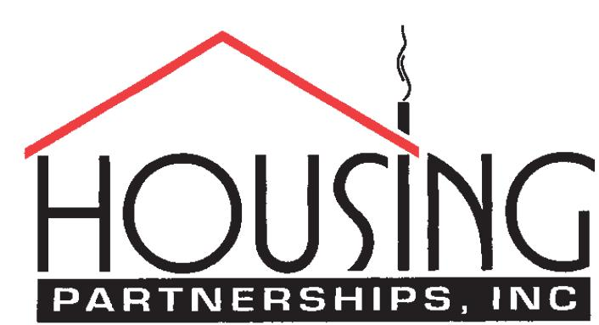
Keeping our neighbors safe, warm and dry since 1985

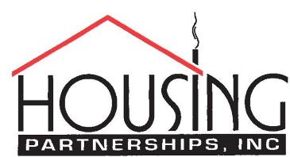

Our Mission
To repair or replace substandard housing in the City of Williamsburg, James City County, and York County, Virginia. Our unique strength is the formation of partnerships between volunteers and our neighbors in need to achieve the goal of safe, warm, and dry housing.

Our Programs
Housing Partnerships (HPI) provides the following services to residents of owner-occupied dwellings in Williamsburg, James City County and York County.
- Emergency Home Repairs - Bathrooms, plumbing, doors, flooring, roofs, water heaters, and electrical.
- Home modifications for persons with disabilities.
- Replacing dilapidated unlivable homes on an as-needed basis.
Housing Partnerships is also the Virginia Indoor Plumbing Rehabilitation Flex Program administrator for the 15-county region extending west to Goochland County and north to Caroline County. This program provides forgivable loans to low-to-moderate income owner-occupants of substandard housing who have no indoor plumbing, including no potable water or a failed septic system.

Our clients
Most of our clients are elderly, and more than one-third are disabled. The average annual income of our clients is about $21,000, with many surviving on Social Security income alone. HPI's work allows our neighbors to stay safely in their homes as they age.



Housing Partnerships—About Us
Housing Partnerships has kept local families safe, warm, and dry since 1985. With a staff of 2½ full-time equivalent employees and hundreds of volunteers, we have performed over 3500 home repairs and modifications over the years and built 56 houses from scratch.
In fiscal year 2022 (July 1, 2022, to June 30, 2023), we assisted more than 189 households in single-family, owner-occupied stick-built homes or manufactured dwellings (primarily trailers). The jobs we performed included:

- Electrical Repairs: 28 | - Plumbing Repairs: 18
- Structural Repairs: 50 | - Accessibility improvements: 30
- Roofing: 25 | - Energy efficiency Improvements: 8
- Heating and Cooling: 10 | - Miscellaneous Repairs: 20

Our Staff

Brandie Weiler, Executive Director
Ashley Mayfield, Program Administrator/Accounting
Pearline Skeeter, Admin Assistant (AARP employee)
Robert Taylor, Program Manager
Roland Dennis, Housing Specialist

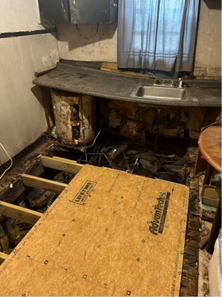  Before | 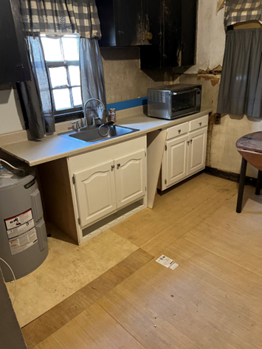  After

Our Volunteers
Volunteers are the heart and soul of Housing Partnerships. Without our dedicated team, we could not serve our community. We are grateful beyond measure for our “Tuesday/Thursday Crew” who come out each week, as well as for assistance from volunteer groups from Bruton Parish Episcopal Church, St. Stephens Lutheran Church, Williamsburg Chapel, The Diocese of Richmond, and Langley Federal Credit Union—to name only a few!
Jobs performed for our clients range from just a few hours to more than 100 hours each. Regardless of the complexity, our volunteers see every job through to completion with compassion for their neighbors in need. Their skill, energy, and time contributions set Housing Partnerships apart from most other non-profits.
Over the years, our volunteers have contributed more than 180,000 hours to our community, saving HPI millions of dollars in contractor labor. Valued at the nationally recognized volunteer rate of $31.80 per hour in 2022, our volunteers' labor contributed more than 141 thousand dollars to HPI in FY2022.

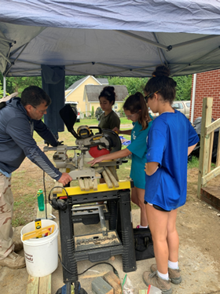 | Pictured left: Volunteers from Diocesan Work Camp joined us June 17-23rd from all over Virginia. These young adults spent the week serving the citizens of the Highland Park Neighborhood, providing much-needed repairs to their homes.  The Diocesan Work Camp completed ten jobs ranging from power washing repairing a wheelchair ramp, to replacing stairs and handrails as pictured here. The cost savings by having this work camp volunteer with HPI was over $20,000.00 in materials and labor. We are excited to welcome the Diocesan Work Camp in the Summer of 2024.
Pictured right: Volunteers Jim and “Doc” on the wheelchair ramp built by the “Tuesday/Thursday” crew.  The need for disability modifications has grown tremendously during the pandemic and post-pandemic. | 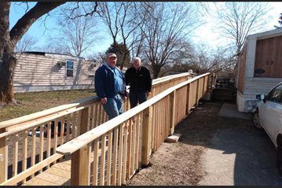

Our Tuesday/Thursday Volunteer Crew
Robert (Bob) Campbell | Jim Overturf
John Horne | Bob Smith “Doc”
Tom Jamison | Johnny Young
Jim Loveland

Client Testimonials
“HPI volunteers truly do this for the love of their community!” – Ms. H.
“We are so grateful to have the ramp for my elderly parents. This will allow them to enter/exit the house safely.”-Mr. P
“The guys are wonderful. They were nice and went above and beyond to ensure everything was correct” -Ms. C.
“The volunteers are truly amazing. They always showed up with a smile and were ready to work…they were men on a mission.” – Ms. W
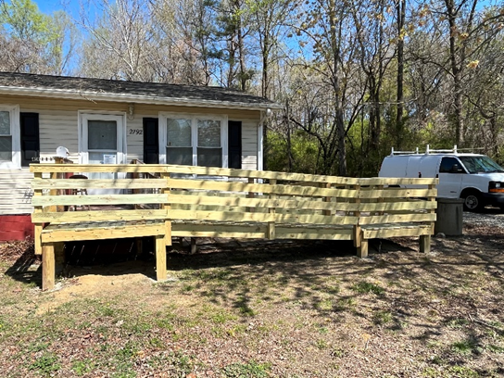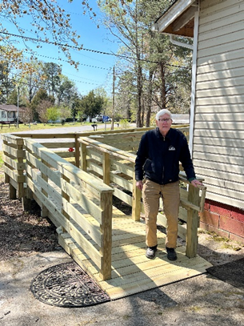
Above is “Doc” Bill Smith, a long-time volunteer with Housing Partnerships. This is a completed ramp for a client. This ramp was built as part of our home modification program. By having our volunteers construct the ramps, this is a cost savings of approx. $3,000 in labor only! Depending on the length, material costs can range from $1,500 to $4000.00.

Our Finances
At Housing Partnerships, our ability to serve our neighbors depends on monetary donations from individuals and businesses, grants from local governments, foundations and community organizations, and contributions of time from our volunteers. Every one of these sources is essential to our operations.

Fortunately, the indirect public support we receive through the United Way increased over the FY2022 levels. Our grant revenue also rose in FY2023, partly thanks to a generous grant from the Langley Federal Credit Union. Special events revenue—primarily from the Turkey Trot—accounted for about 13% of total revenues. Finally, our volunteers donated 500 hours of time in FY2023. When monetized at the nationally recognized value of a volunteer hour (a modest $31.80 per hour), this volunteer labor accounted for 3% of our income.
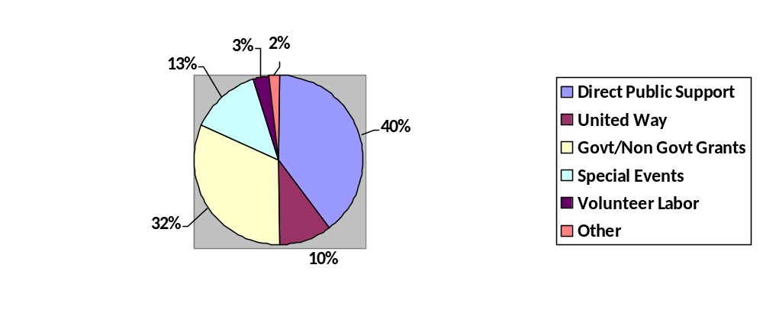

On the expense side of our balance sheet, we spend the money we receive on project supplies, maintaining our office, and employee salaries and benefits. Fundraising accounted for less than XX% of our total expenses.

Special Events
Williamsburg’s First Annual Food Truck
The Williamsburg Food Truck Festival- our newest annual fundraiser- kicked off in June 2023. The fundraiser was made possible by Virginia Housing as the sponsor. The fundraiser was a four-hour event held at the Williamsburg Community Building and featured six food trucks- of different styles- and the musical accompaniment of Good Shot Judy. As the first of its kind in Williamsburg and a new event for Housing Partnerships, the fundraiser was highly successful. Tickets were sold out a week before the event, and interested parties purchased tickets throughout the fundraiser.
We hope to continue this fundraiser and you’ll join us in June 2024—location TBD.
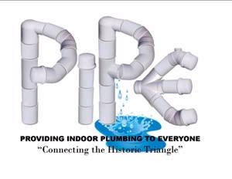
Since 2007, Housing Partnerships' premier annual fundraising event has been our PIPE (Providing Indoor Plumbing for Everyone) Concert. The PIPE Concert is made possible through the support of local business sponsors and individuals throughout our community. Proceeds from this concert and state financing have allowed us to retrofit the homes of ten families in our community to allow indoor plumbing installation. But the job isn't done yet. About 40 families in our area still lack the necessities for healthy living.

We have traditionally held the PIPE Concert each September at the Martha Briggs Amphitheater on the William and Mary campus. For ten years, the concert featured one of the country's best Jimmy Buffett tribute groups, Pirates of the Caribbean. It's been a wonderful, family-friendly evening enjoyed by hundreds of our neighbors and provided much-needed support for the work of Housing Partnerships.
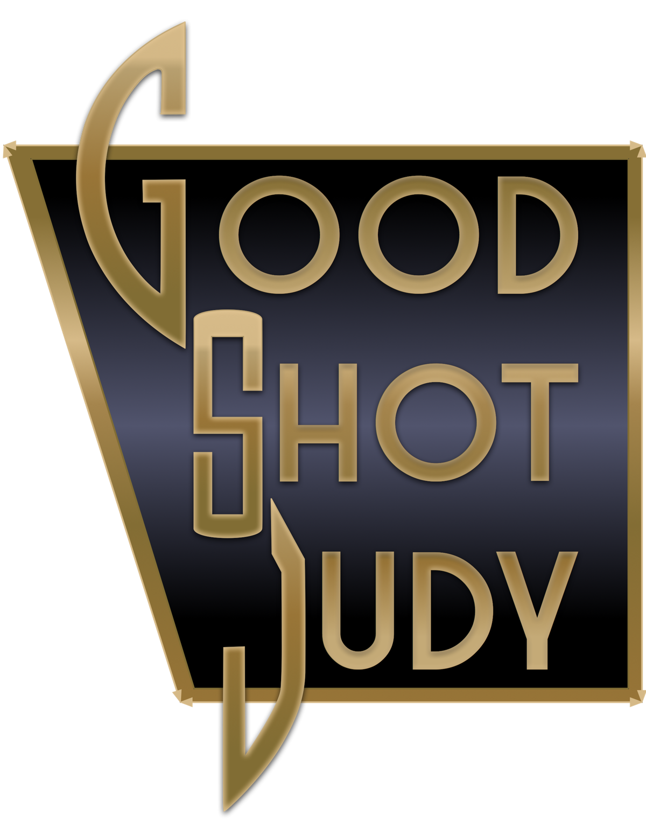
After delaying our 2020 PIPE concert due to COVID-19, we wanted to bring PIPE back with a different vibe. In 2022, we invited a new band, Good Shot Judy, and moved the location to High Street. The concert was a hit, pulling in music lovers of all types. In October 2023, we brought Good Shot Judy back for an encore performance as we celebrated our 15th Annual concert. Up next…PIPE 2024, coming September 2024, details TBD.



In Memory
Virginia “Ginny” Wertman
May 31, 1948- July 11, 2022
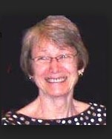
July 11, 2022, Housing Partnerships lost a true leader, advocate, and Chairman of our Board of Directors. Ginny was not only the chair of our BOD, but she was known by many in our community for serving on various boards, and her involvement in the community was astonishing. Ginny was our biggest fan at Housing Partnerships and a dear friend. Her absence is felt daily. Ginny and her husband, Dr. Stan Bolding, were long-time donors to Housing Partnerships as well. We sincerely thank Stan and Ginny for all they did for Housing Partnerships. We strive to keep Ginny’s memory with us at Housing Partnerships. Below is her Obituary published in the Virginia Gazette on July 23, 2022.
Ms. Wertman was born May 31, 1948, at Lakewood Hospital, Lakewood, Ohio. Virginia was the daughter of the late Daniel and Edith Wertman. She fought a courageous five-month battle against metastatic lung cancer and succumbed at home on July 11, 2022.
Virginia attended Lakewood High School, where she was a member of the student counsel and the National Honor Society. She attended the Women's College of Duke University and obtained a B.A. In Economics with a minor in Econometrics.
Ms. Wertman began a rewarding and highly successful professional career in 1970, when she joined the staff of Wharton Econometric Forecasting Associates, Inc. (WEFA), a wholly-owned subsidiary of the University of Pennsylvania. WEFA was founded by the late Lawerance R. Klein who was CEO of WEFA, the Benjamin Franklin Professor of Economics at Penn, and the 1980 recipient of the Nobel Prize in Economics. During her nine-year tenure at WEFA, Ms.Wertman was Director of Communications and Data Base Operations. She wrote and published a weekly economic newsletter that was distributed to WEFA's clients and managed the staff that maintained WEFA's enormous databases.
In 1983, Ms. Wertman began a three-year contract to maintain a clearinghouse with the National Alliance of Businessmen (NAB), a program established in 1968 by President Johnson and Henry Ford II and funded by the U.S. Department of Labor. NAB provides resources to prepare poor adults and youth with the skills necessary to have successful careers in the private sector.

In 1986, Ms. Wertman joined the staff of the International Monetary Fund (IMF). During her 23 years at the (IMF) she served in the following: the World Bank-IMF Joint Computer Center; the Monetary Affairs Department, the Africa Department, the Office of Internal Audit and Inspection, where she assessed the effectiveness of the IMF's governance, risk management, and internal controls and acted as a consultant to improve the IMF's business processes; and in the Information Technology Department as a Senior Adviser.
In 2009, Ginny and Stan moved to Williamsburg, and she began her second career. She was a James City County (JCC) Election Official. Ginny was a member of the JCC Workforce Housing Task Force. She served on the Planning Commission Working Group and was also Chair of the Citizen Participation Team, which was appointed by the Board of Supervisors to lead and promote public engagement for development of Our County, Our Shared Future, the JCC 2045 Comprehensive Plan.
Ginny was an active member of the Williamsburg Coalition for Community Justice; Chairman of the Board of Housing Partnerships,Inc, Vice Chair for Membership and Outreach for the WJCC Democratics; and a member of the York-Williamsburg-James City NAACP branch.
Ginny was an excellent cook, though she would deny it, a voracious reader, and enjoyed working the yard in Williamsburg and on the couple's 53 acres in the Shenandoah Valley. Earlier in the couples marriage, she enjoyed their excursion around the country in their C-177RG and became an excellent co-pilot.
Stan and Ginny loved animals and had five canines and one cat during their marriage. In the last eight years, she was the sole caregiver to Stan who has severe emphysema. Most of all, Ginny was a thoughtful, caring and loving person who was an absolute joy to be around.
Stan is grateful for the support Gin received from Jen Tierney, MK Sizemore, Bill Stauffer, Camilla Buchanan, Debra Hill, John McGlennon, Jim and Linda Icehour, Fred and Shelley Donnell, and her many other friends during her five-month battle.
Ginny is survived by her loving and devoted husband of 41 years, her sister Cheryl Johansen, and nieces Lisa (Yoder) Martin (Brad), Laura (Yoder) DeCoste (Ken), and Dr. Lesley Yoder of Acton, MA.
A Celebration of Ginny's Life will be held at the Williamsburg Unitarian Universalists Church, 3051 Ironbound Rd, Williamsburg, VA at 2:00PM, Sunday, July 31st, followed by a reception in the church hall. In lieu of flowers, please make a contribution in Ginny's name to Housing Partnership, Inc., P.O. Box 441, Williamsburg, VA 23187

We want to acknowledge and express our sincere thanks to our sponsors who have donated to make the coming PIPE Concert a success.
2023 PIPE Concert Sponsors
AES | Kamco Services
Al's Landscape | Land Tech Resources
Apple Door Systems | Parsley Septic Tanks, Inc.
Colonial Sport | Peninsula Custom Coaters, Inc.
Mr. and Mrs. Charles F. Crone | Peninsula Heating and Air
Chesapeake Bank | Mr. and Mrs. Jim Penny
Custom Builder Supply | Town Management
Custom Welding | Riverside Brick
Daniel's Welding | Mark’s Pest Control
Geddy, Harris, Franck and Hickman, LLC | James River Equipment
Guernsey Tingle Architects | Stemann Pease Architects
Five Nines Company | Structures Group
Fine Signs | Taproot Hearth
Harry's Mobile Repair | Toano Contractors
High Street Williamsburg- Lamar Companies | Van Kniest Painting and Finishes, Inc.
Hopke and Associates | Virginia Woodcrafters
Mr. and Mrs. Ronald Hurst | Mr. Mark Wenger
Jimmy Engine Services | Williamsburg Dental Group
Kiskianc Golf | Mr. and Mrs. Carl Zangardi
Kaufman and Canles

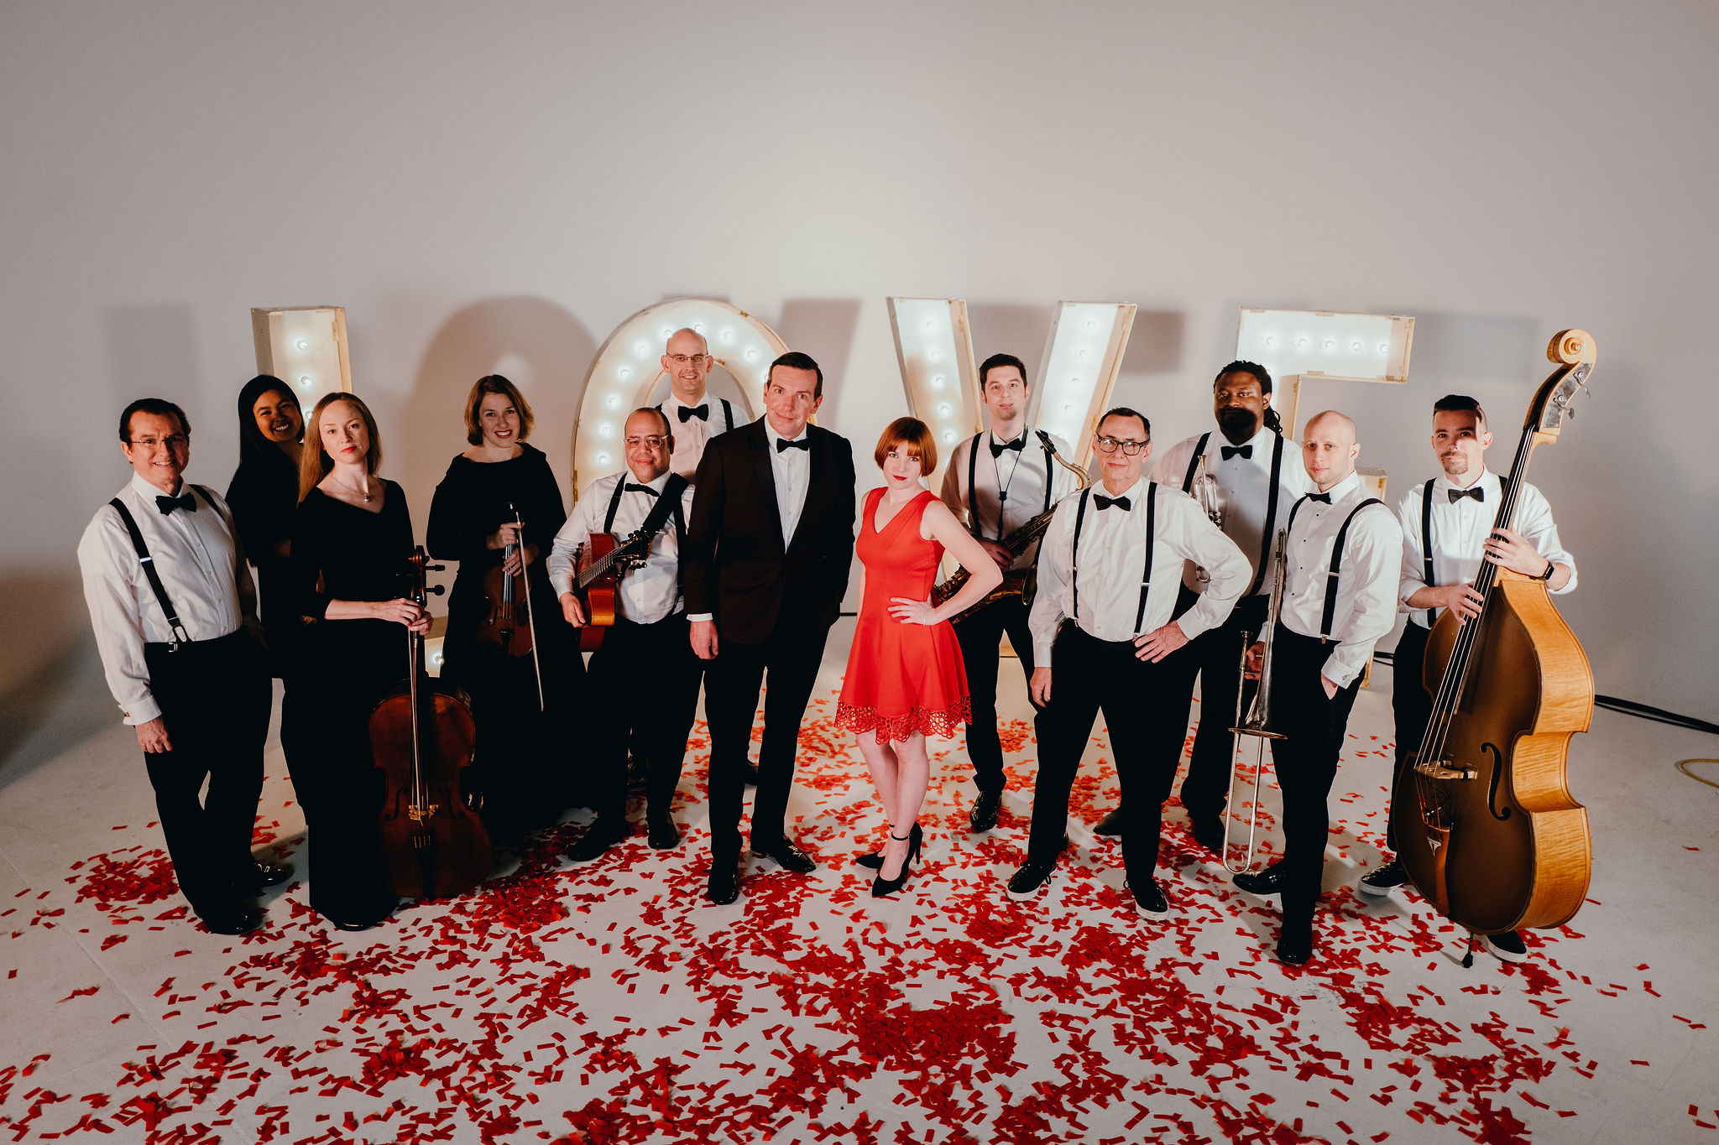
Good Shot Judy

FY22-23 Individual Donors

Ms. Christine Allison | Mrs. Patricia Moore
Mr. Robert B. Archibald & Ms. Nancy A. Vincent | Mr. and Mrs. Timothy Murphy
Mr. and Mrs. Curtis Baker | Mr. and Mrs. Reed T. Nester
Mr. and Mrs. Lou Bartek | Mr. and Mrs. Michael Nice
Mr. and Mrs. Berry Beers | Mr. and Mrs. Terry O’Connor
Mr. and Mrs. Alan Bolash | Mr. and Mrs. William O’Donovan
Mr. and Mrs. Jeff Brittle | Porush
Mr. and Mrs. Michael J. Brown | Mr. and Mrs. Tony Pauroso
Mr. and Mrs. Robert Burke | Mr. and Mrs. James Penny
Mr. and Mrs. John P. Carey | Mr. and Mrs. John Perkins
Mr. Robert Carlson | Ms. Shanna Robillard
Cardaropoli | Mr. and Mrs. Michael Rock
Mr. Ronald Chappell | Mr. and Mrs. Stephen Romeo
Ms. Katherine Cheves | Mr. and Mrs. W.S. Sadler
Mr. Shelton Cockrell | Mr. Edward and Mrs. Catherine Sadowski
Mr. Richard Costello | Dr. and Mrs. Lawrence Sarmiere
Mr. and Mrs. Charles Crone | Mr. and Mrs. Harlan Schone
Mr. and Mrs. John R. Curtis, Jr | Mr. and Mrs. Richard H. Seward
DeCoste | Mr. and Mrs. Marc Sharp
Mr. and Mrs. Andrew Franck | Mr. William Smith, Jr.
Mr. and Mrs. Thomas French, Jr | Mr. and Mrs. Peter Socha
Mr. and Mrs. Charles Frey | Ms. Sarah Stafford
Dr. and Mrs. Gilbert J. Frey | Mr. James Stillwell
 | Mr. Hans Tiefel and Ms. Janna Fitzgerald
Mr. and Mrs. Robert Grafton | Thompson
Haldeman | Dr. Edward H. Tiller, Ph.D.
Mr. and Mrs. Jack Harris | Mr. and Mrs. Tom Tingle
Haulman | Mr. Robert Voigt
Houff | Mr. Sandford Wanner
Mr. and Mrs. John Horne | Mr. and Mrs. Stephen Watkins
Mr. and Mrs. Mark Howell | Mr. Robert E. Welsh and Ms. Karen M. Rose
Mr. and Mrs. Ronald Hurst | Mr. Mark J. Wenger
James | Dr. H. Stanley Bolding
Ms. Judy Beth Jones | Ms. Elizabeth Wieland
Mr. William Kellam | Mr. John Wilson
Mrs. Anne Kelly | Wright
Mrs. Christine King | Mr. and Mrs. James Woodall
Mr. and Mrs. Charles Kinnamon | Mr. and Mrs. Carl Zangardi
Mr. Aaron Konicki | Voigt
Ms. Ann Lee | The Honorable and Mrs. J.R. Zepkin
Dr. William Lee | Ms. Sharon M. Maloney
Levine

FY22-23 Business Donors

AES Consulting Engineers | Langley Federal Credit Union
Aleworks | Mason Pasquin Agency
Al's Landscaping Co., LLC | Michael C. Rock Agency, Inc.
Apple Door Systems | Michael J. Hipple, Builder Inc.
Blue Talon Bistro, LLC | MIKA Electric Co., Inc.
Buntrock Industries, Inc. | Parsley Septic Tank Service Inc.
Cason Custom Homes LLC | Peninsula Custom Coaters, Inc.
Charles W. Ross Builders, Inc. | PHA INC. DBA Peninsula Heating & Air
Chesapeake Bank | Promark Custom Homes
Coldwell Banker Traditions | Re/Max Capital
Custom Builder Supply | Riverside Brick & Supply Co
Custom Welding, Inc. | RJS & Associates, Inc.
Daniels Welding and Tires, Inc. | Ronald Curtis Builders, LLC
Five Nines Company | Schwab Charitable
Geddy, Harris, Franck & Hickman, L.L.P. | Simmons Engineering, Inc.
George Nice & Sons, Inc | Stemann Pease Architects
Guernsey Tingle Architects | Taproot Hearth & Patio
Harry's Mobile Repair, Inc. | The Structures Group, Inc.
Hopke & Associates | Toano Contractors, Inc
I Shine For You, LLC | Towne Bank
International Monetary Fund | Van Kniest Painting & Finishes, Inc.
J.S.G Corporation | Virginia Grounds, LLC
James River Equipment - Toano | Virginia Woodcrafters, Inc
Jeffrey N. Clark Custom Builder, LLC | William F. Miller, PC
KAMCO Services | Williamsburg Dental Group
Kaufman & Canoles, P.C. | Junior Women’s Club
Knicely Law Firm | Ross Builders
Landtech Resources, Inc.

FY22-23 Faith Organization Donors
First Baptist Church | St. Stephen's Lutheran Church
King of Glory Lutheran Church | Williamsburg Baptist Church
New Zion Baptist Church | Williamsburg Presbyterian Church
Olive Branch Christian Church | Williamsburg United Methodist Church

FY22-23 Civic Organizations, Foundations, and Trust Donors
Langley for Families Foundation
Robert McEldowney Jr Family Foundation | The RBWR Family Charitable Foundation Inc.
Rotary Club of Williamsburg | Williamsburg Community Foundation

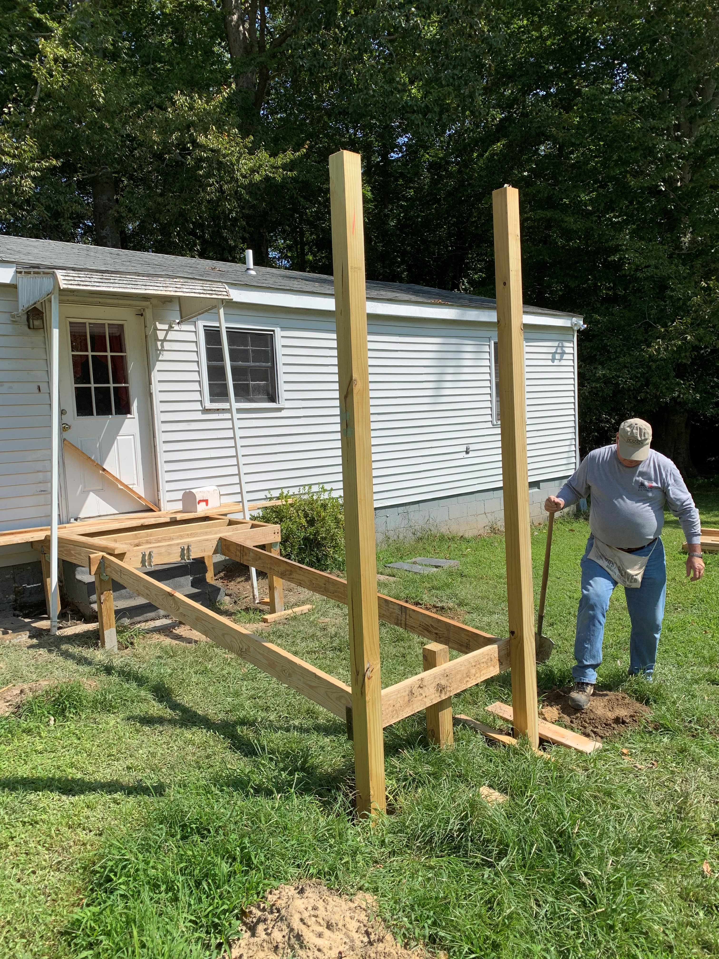 | 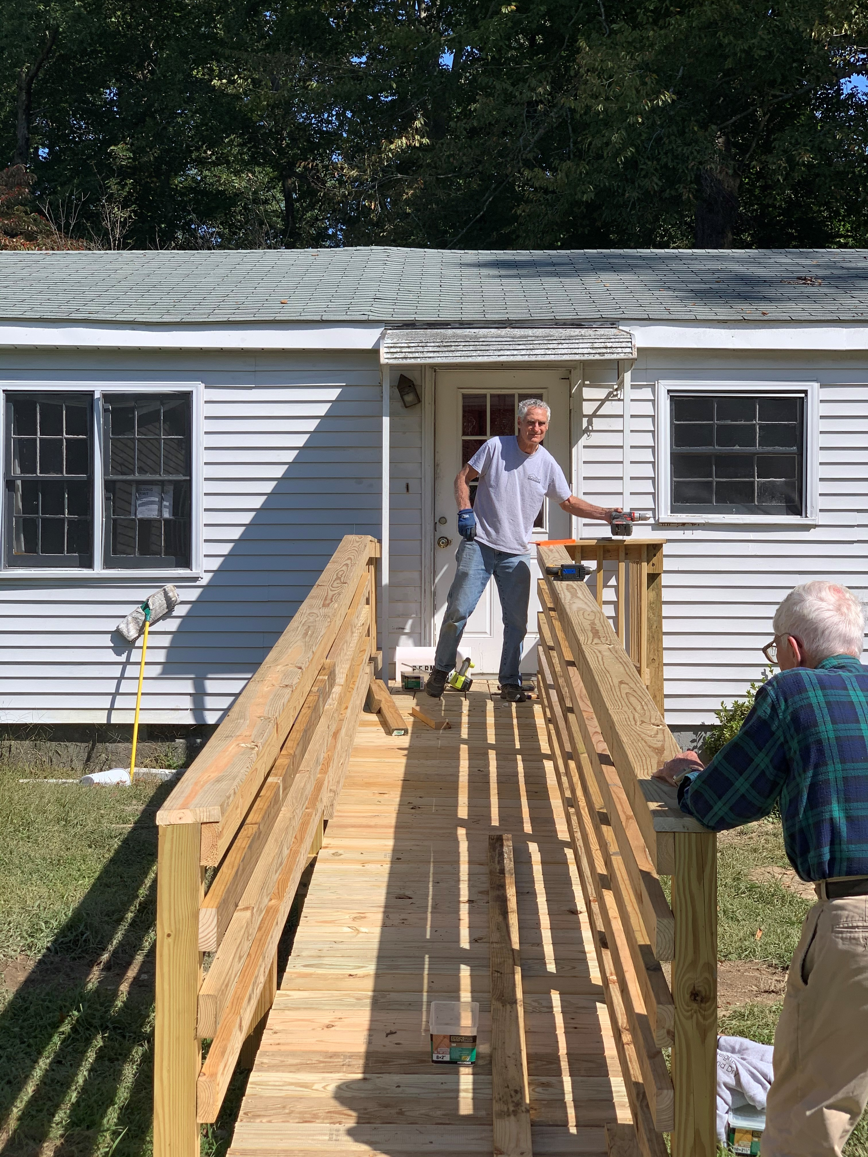
Volunteers Jim Lovelend (left) and John Horne (right) building a much-needed handicapped ramp for an HPI client.

